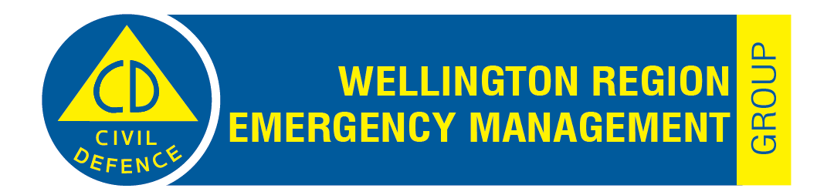

Please note these minutes remain unconfirmed until the Wellington Civil Defence Emergency Management Group meeting on 13 June 2023.

Report 23.86
Public minutes of the Wellington Civil Defence Emergency Management Group meeting on Tuesday 7 March 2023
Taumata Kōrero – Council Chamber, Greater Wellington Regional Council
100 Cuba Street, Te Aro, Wellington, at 11am.
Members Present
Mayor Anita Baker (Chair) Porirua City Council
Hon. Mayor Ron Mark (Deputy Chair) Carterton District Council
Mayor Campbell Barry Hutt City Council
Mayor Gary Caffell Masterton District Council
Mayor Wayne Guppy Upper Hutt City Council
Mayor Janet Holborow Kāpiti Coast District Council
Council Chair Ponter Greater Wellington Regional Council
Mayor Whanau Wellington City Council
Public Business
- Apologies
Moved: Mayor Baker / Mayor Whanau
That the Joint Committee accepts the apology for absence from Mayor Connelly.
The motion was carried.
- Declarations of conflicts of interest
There were no declarations of conflicts of interest.
- Public participation
There was no public participation.

Mayor Baker, Chairperson of the Wellington Civil Defence Emergency Management Group, announced her resignation as the Chairperson, and vacated the Chair.
Hon. Mayor Mark, Deputy Chairperson, assumed the Chair.
- Election of the Wellington Civil Defence Emergency Management Group Chairperson – Report 23.67
Hon. Mayor Mark spoke to the report.
Moved: Mayor Baker / Mayor Whanau
That the Joint Committee:
- Notes that the Chairperson will hold office until the next triennial local government elections.
The motion was carried.
Moved: Council Chair Ponter / Mayor Guppy
- Adopts, pursuant to Schedule 7 of the Local Government Act 2002, Appointment by statutory voting system B.
The motion was carried.
Moved: Mayor Barry / Mayor Caffell
- Agrees that any voting that requires resolution by ‘lot’ to exclude any person/s will use the procedure where candidates’ names (with the same number of votes) are placed in a container and the name of the person drawn out by an independent person is deemed the winner (i.e. elected, or not excluded from the next round).
The motion was carried.
4.1 Appointment of Chairperson
The Presiding Member, Hon. Mayor Mark, called for nominations for the position of Chairperson of the Wellington Civil Defence Emergency Management Group.
Moved: Mayor Baker / Council Chair Ponter
That the Wellington Civil Defence Emergency Management Group appoints Mayor Whanau as Chairperson.
There being no further nominations, Mayor Whanau was declared the Chairperson of the Wellington Civil Defence Emergency Management Group.
Hon. Mayor Mark vacated the Chair on the election of Mayor Whanau as Chairperson, and Mayor Whanau assumed the Chair.

- Confirmation of the Public minutes of the Civil Defence Emergency Management Group meeting on 6 December 2022 - Report 22.528
Moved: Mayor Baker / Mayor Holborow
That the Joint Committee confirms the Public minutes of the Civil Defence Emergency Management Group meeting on 6 December 2022 – Report 22.528.
The motion was carried.
- Wellington Region Emergency Management Office Quarterly Report – Quarter Two, 2022-23 – Report 23.72
Jeremy Holmes, Regional Manager, WREMO, spoke to the report.
Moved: Mayor Holborow / Council Chair Ponter
That the Joint Committee approves the Wellington Region Emergency Management Office Quarter Two Report – 1 October to 31 December 2022, as an accurate reflection of progress against the Wellington Region Emergency Management Office Annual Plan.
The motion was carried.
- Wellington Civil Defence Emergency Management Group Appointments – Report 23.71
Jeremy Holmes, Regional Manager, WREMO, spoke to the report.
Moved: Mayor Baker / Mayor Barry
That the Joint Committee:
- Approves the addition of the following statutory appointees:
  - Kane McCollum as Alternate Group Controller
  - Benjamin Vollebregt as Primary Controller for Wellington City Council
  - Angela Bell as Alternate Controller for Kāpiti Coast District Council.
The motion was carried.
- Recent Event Reflections: Auckland Flooding; Interislander Ferry Engine Failure; Cyclone Gabrielle – Oral Report
Jeremy Holmes, Regional Manager, WREMO, provided an oral briefing on the Auckland, flooding event, the recent Interislander passenger ferry engine failure, and Cyclone Gabrielle.
Auckland Flooding:
Mr Holmes advised the Committee that Auckland Council has initiated an independent review of the performance of the Auckland Council before, during, and after the January 2023 flood event. The current review of the CDEM Act will take account of what is learnt from this event and the later Cyclone Gabrielle event. The Committee noted the issues that can arise when there is a hiatus between media and social media reporting of a rapidly escalating event and relevant CDEM communications to affected communities.
Interislander engine failure
Mr Holmes advised of the prompt action taken by WREMO, Wellington City Council, and other agencies, when advised of the engine failure on the Interislander passenger ferry Kaitaki on 28 January 2023. The Committee noted that the absence of offshore towing capacity for large vessels is a national issue and that Greater Wellington Regional Council has raised this issue with Maritime New Zealand and other stakeholders.
Cyclone Gabrielle
Mr Holmes advised the Committee of the significant personnel and logistical support provided by WREMO and council staff in the wellington region to the response to both the Cyclone Gabrielle and Auckland flood events.
Within the Wellington Region the cyclone had significant impacts in areas of the Wairarapa. Dan Neely, Group Recovery Manager, WREMO, advised that meetings of mayors, iwi and community groups have been held to help develop the terms of reference for the Wairarapa Recovery Group; this will provide the foundation for the development of the Wairarapa recovery action plan, community engagement plan, and the process for access to funding streams.
The public meeting closed at 11.41am.

Mayor Tory Whanau
Chair
Date:

